**CC-215-L: Database Systems Lab**

*Faculty of Computing & Information Technology*



**BSCS Morning - Fall 2021, Semester Spring 2023**

**LAB – 01**

**Course & Lab Instructor:** Dr. Asif Sohail

**Objectives:**

1. Installation && Setting Up Lab environment
2. Basic Select Statements

*Allowed time: 90 mins.*

***Instructions:***

1. Gossips are not allowed.
2. Teacher assistants are for your help, so be nice with them. Respect them as they are teaching you. Raise your hands if you have some problem and need help from TA. Avoid calling them by raising your voice and disturbing the environment of Lab.
3. TA may deduct your marks for any kind of ill-discipline or misconduct from your side.
4. Evaluation will be considered final and you cannot debate for the marks. So, focus on performing the tasks when the time is given to you.
5. Paste the query as well as result table screenshot as a result of each task

**Sample:**

**Display All the Employees from emp table**

**Solution:**

**Select * from emp**

|  |  |  |  |  |  |  |  |
| --- | --- | --- | --- | --- | --- | --- | --- |
| **EMPNO** | **ENAME** | **JOB** | **MGR** | **HIREDATE** | **SAL** | **COMM** | **DEPTNO** |
| 7369 | SMITH | CLERK | 7902 | 12/17/1980 | 800 | - | 20 |
| 7499 | ALLEN | SALESMAN | 7698 | 02/20/1981 | 1600 | 300 | 30 |
| 7521 | WARD | SALESMAN | 7698 | 02/22/1981 | 1250 | 500 | 30 |
| 7566 | JONES | MANAGER | 7839 | 04/02/1981 | 2975 | - | 20 |
| 7654 | MARTIN | SALESMAN | 7698 | 09/28/1981 | 1250 | 1400 | 30 |

**Task 01: [10 Marks]**

1. Configuration of Apex Oracle Online **(2)**
2. Oracle 11g Express Installation **(4 Marks)**
3. Uploaded The Tables (EMP,DEPT , SALGRADE , PUCIT) **(4 Marks)**

**Task 02: [10 Marks]**

1. Retrieve all rows of the table Salgrade and PUCIT.

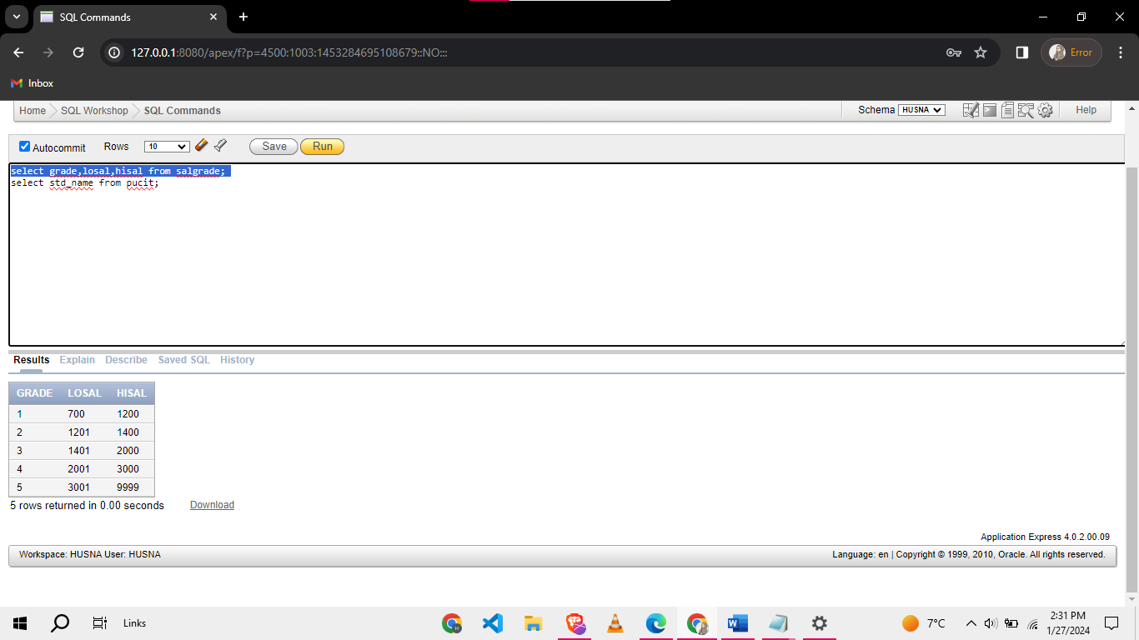

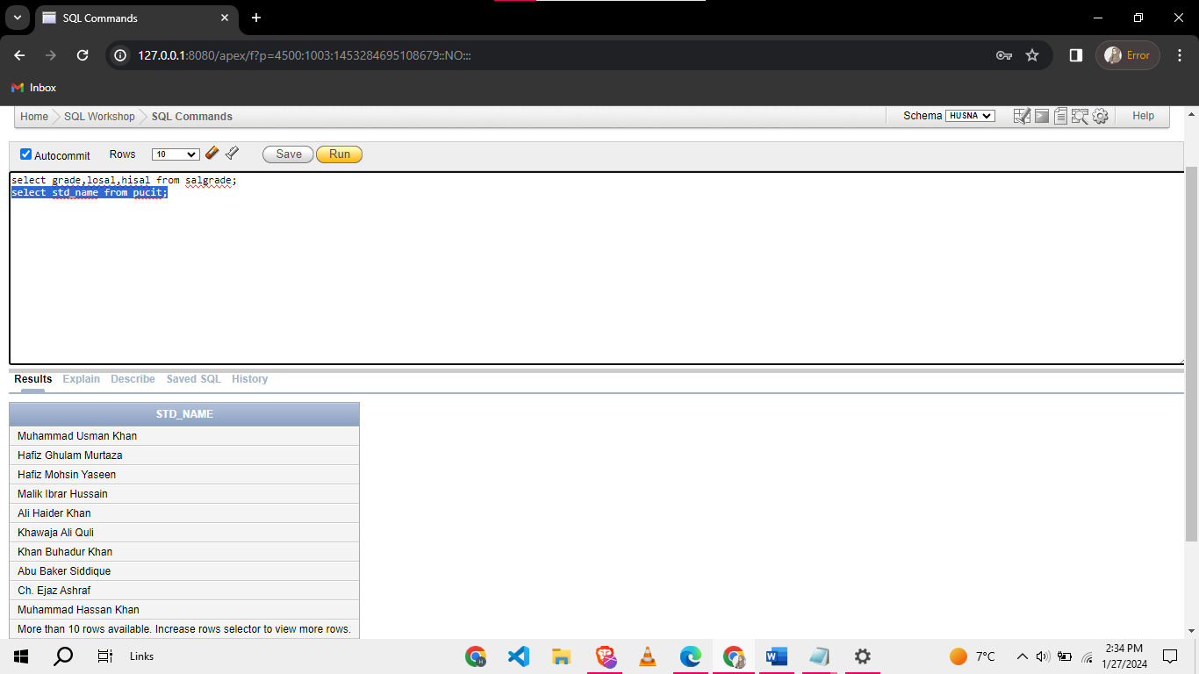

1. List Department name and its location from the table DEPT.

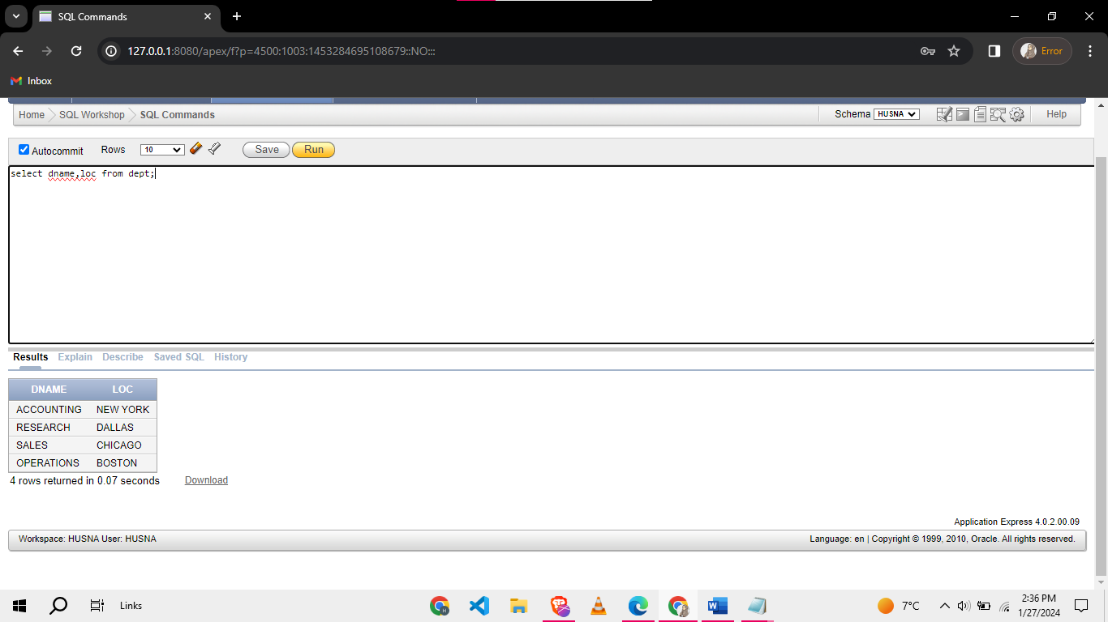

1. List all Employees’ numbers and Employees’ names and when they are Hired from EMP.

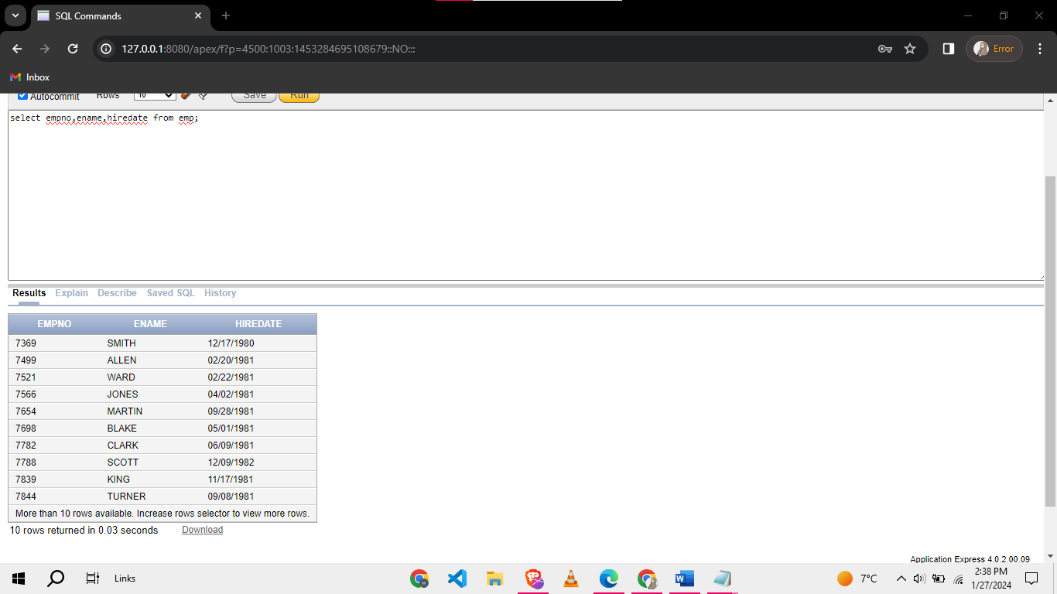

1. Find the Grade from Salgrade Table having Difference of salaries Greater than 1000.

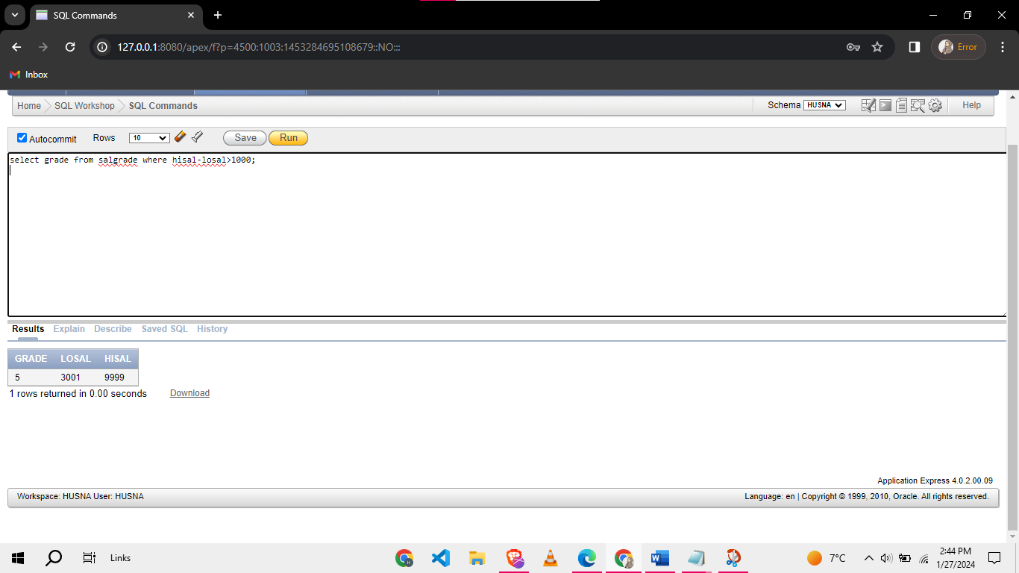

1. Calculate the Monthly Salary for each employee.

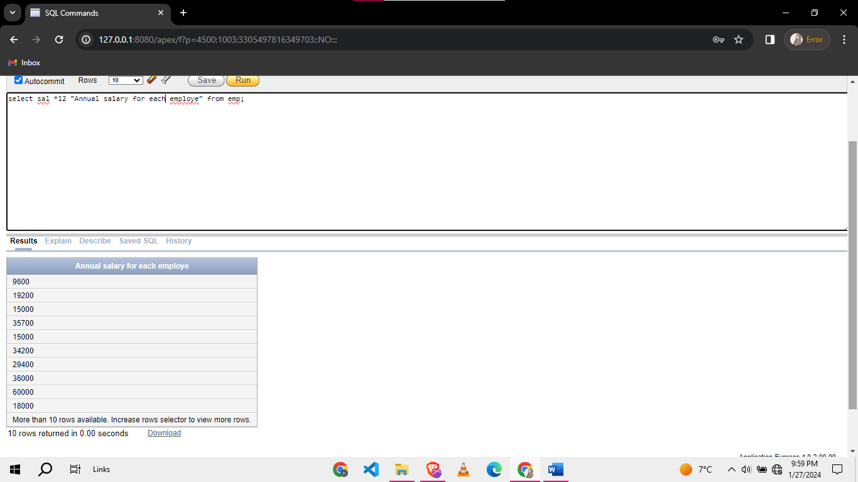

1. Calculate the projected salary after a 15% increase with their taxes (Tax = SAL * 0.2) for all employees.

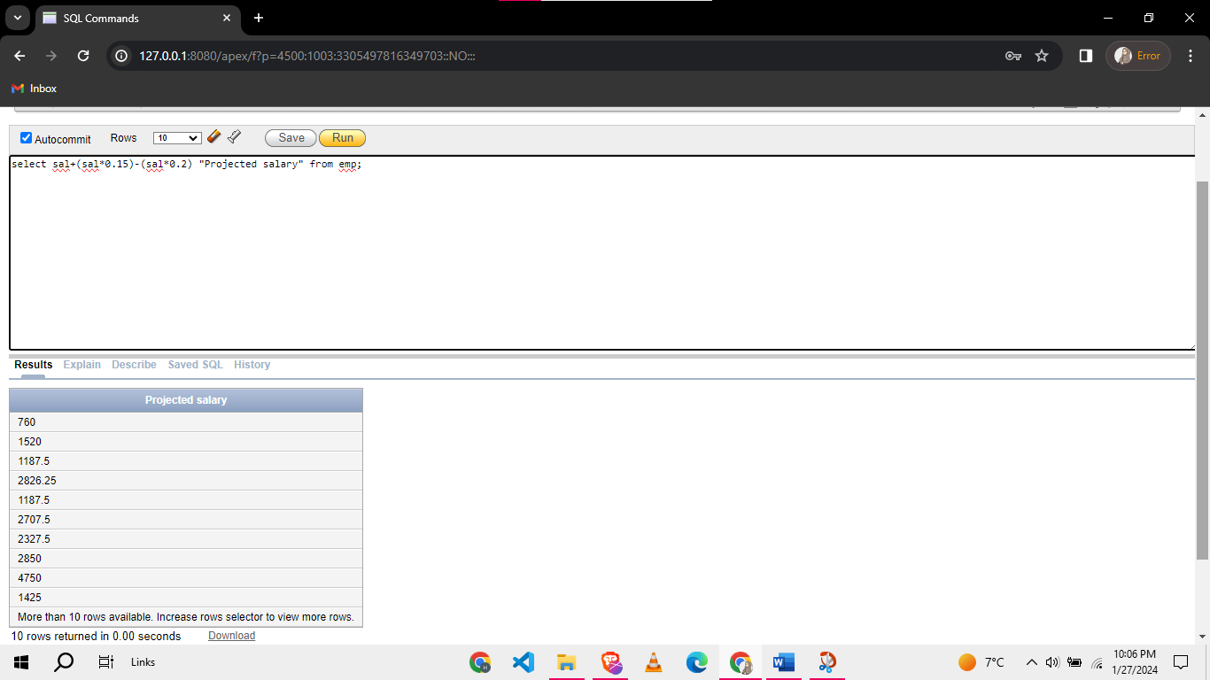

1. Display The outputs in format:

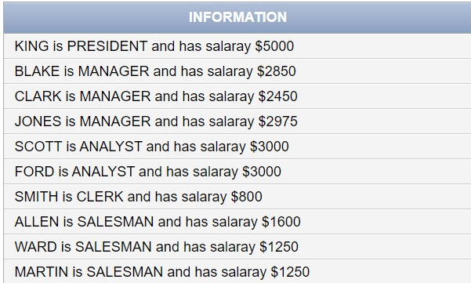

1. List the employees manager working under the having id=7566.

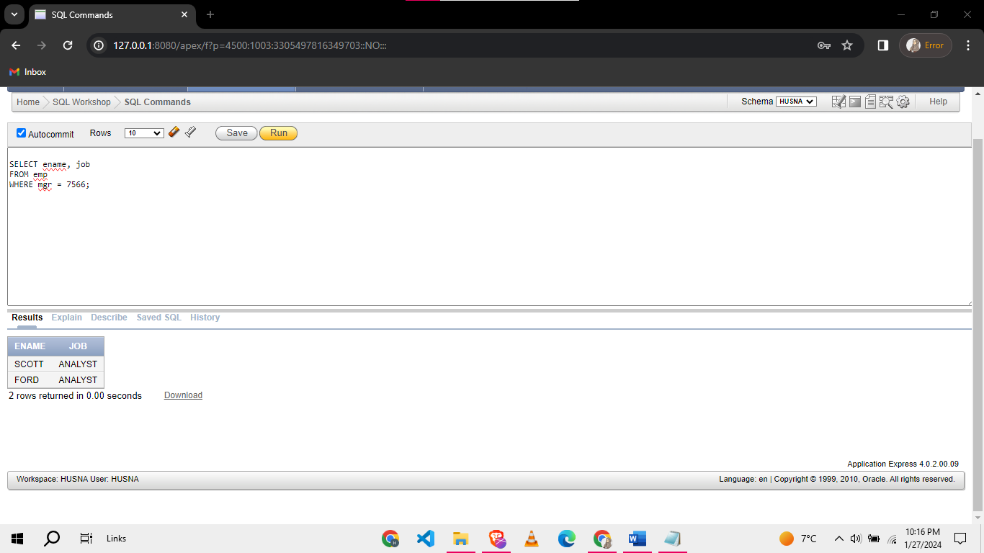

1. Retrieve Employee Name having salary is greater than 2000 and whose Manager is Ford.

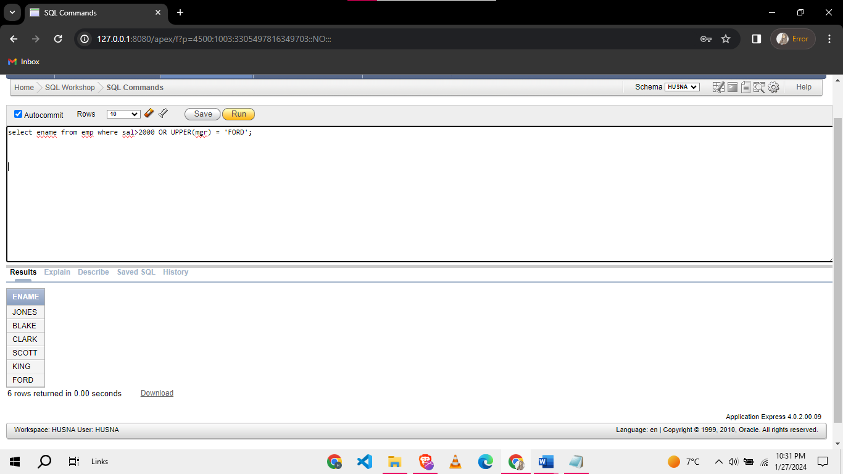

1. Retrieve all the employees hired after 2-22-1981.

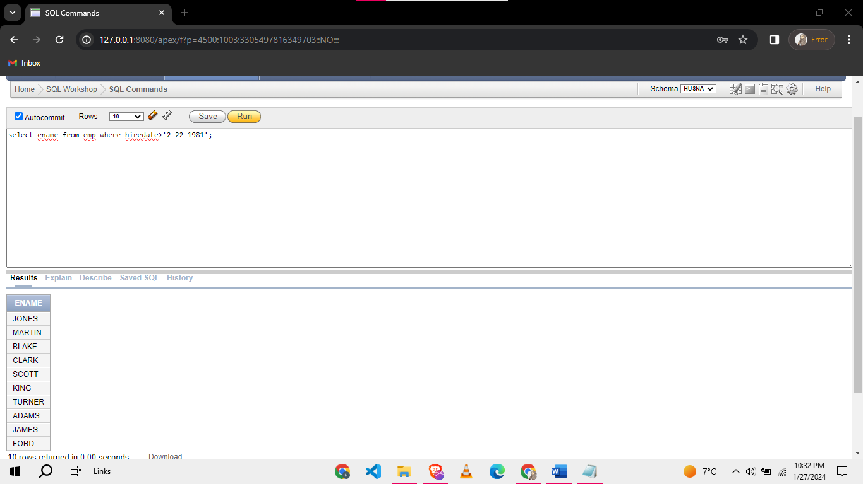

1. Find All the name of Employees Working in department 10 or 30 having salary less than 2000.

